How to Register Your Hall Council:
What you need to complete the Hall Council Registration:
- The Hall Council Roster updated to reflect the current President, Vice President, Treasurer, Secretary, RHA Senator 1, RHA Senator 2 and a Faculty/Staff Advisor.
- An updated constitution with any changes that RHA has asked the Hall Council to make.
How to Invite people to your page:
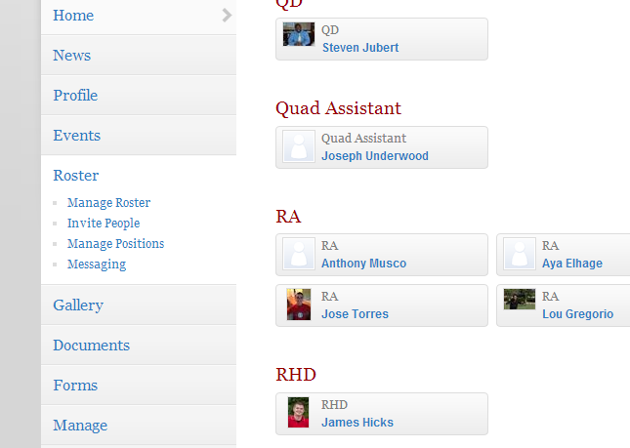
You can use this to copy and paste your entire floor roster of your building OR invite your executive board members and assign position:
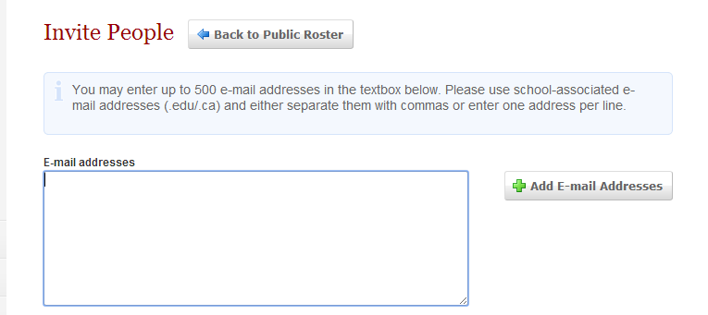

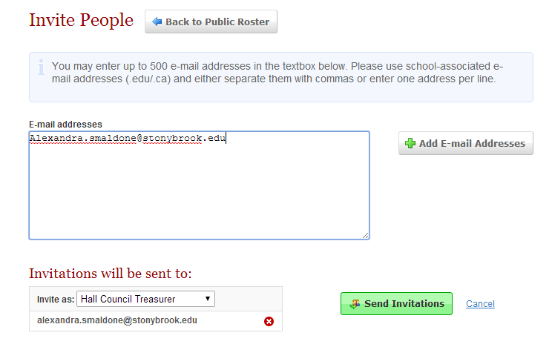
After you input the executive board member’s email, it will populate to assign them a position. *If you are inviting your whole building, you can assign them all as members. If your executive board member is already in the roster, you can go to “Manage Roster” under the Roster functions.

After registration if you have a position such as Community Service Coordinator, you can add that position by going to Manage Positions under the Roster function.
*It is best to complete this step before starting registration for you building (Hall Council)

Step 1: Go to your organization and click “Register This Organization”
Notes: You’ll need your roster to be updated within Collegiate Link and your constitution to be updated (you need to upload it) before you start the registration process. See the separate document for How to Manage Positions to create your roster for your buildings.

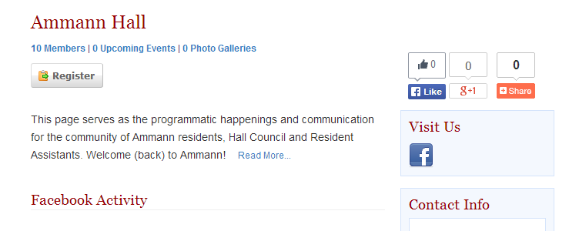

Step 2: Read the information about registering. Then click Next.
Step 3: Update any General Information about your Hall Council.
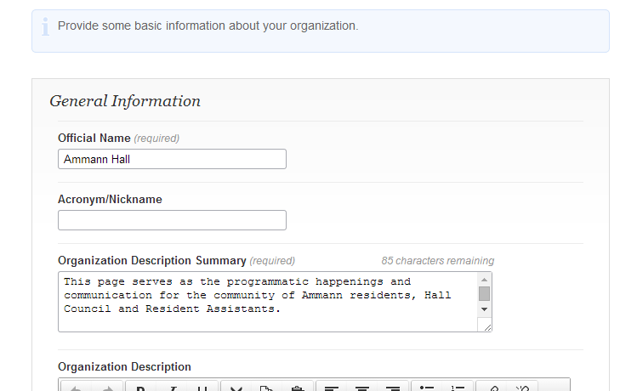

Step 4: Change the Hall Council Profile picture if you want. (You can change this later too).
Step 5: Make sure your Building Roster is updated (Hall Council Positions).
Notes: Each building needs to register their President, Vice President, Secretary, Treasurer, 2 RHA Senators and their Faculty/Staff Advisor. The green check marks will tell you if you have assigned someone to those positions or not. You do NOT need your QD for this purpose, however, each page has a QD assigned already. You will need to add members ahead of time that are will be officers by going to manage roster on the left hand side of your SB Life Page and Inviting them to the page.

Step 6: Upload an updated copy of the Hall Council Constitution.
Notes: It should include RHA Senator updates and any other update instructions from the Stony Brook Communications Coordinator.

Step 7: Agree to the verification and terms of registration.
Step 8: Your registration has been submitted!
A few more notes:
- Along with this registration form, Hall Councils will need to complete a Signature Verification Form and turn it into the RHA Office as well as attend the Hall Council Retreat.
- If your submission is approved, you will become the Primary Contact of the organization. Continue only if you are to be the Primary Contact on record for the organization. This can be changes later, but please be aware of who you want the Primary Contact for the organization to be.
- Your registration is not complete until RHA has approved your registration. We will be looking through all of the registrations to make sure they are accurate and complete. You will receive an email notifying you that you are registered and ready to allocate or if changes need to be made. Please be checking your email and messages on SBLife.
- Hall Councils will not be able to allocate and use their funds until their registration has been complete and approved.
- Registration is due September 20, 2013 by 5pm.
- Any questions please call or email Jay Hicks at james.hicks@stonybrook.edu.

